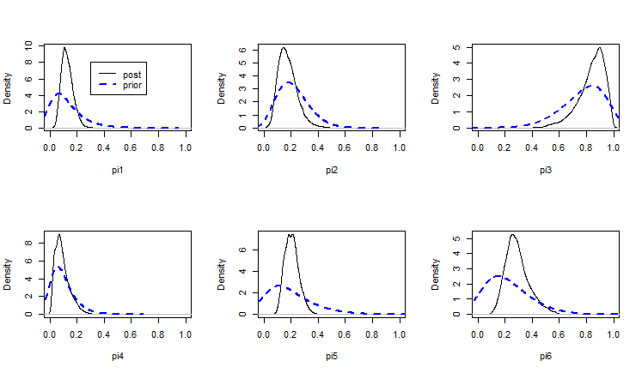

**Figure 1.** Priors and Posteriors

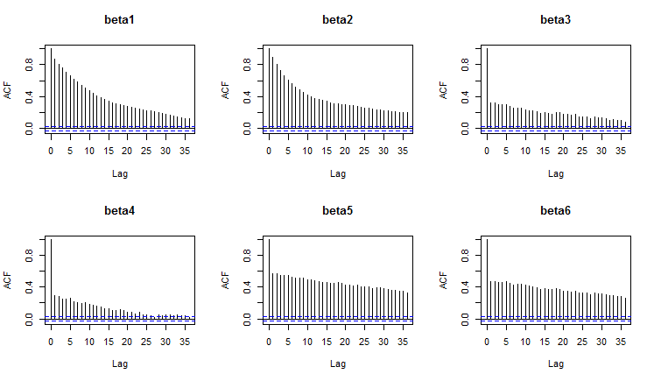

**Figure 2.** Autocorrelation plots. Not particularly healthy, suggesting that we do need to run for a quite a while longer (as compared to say results from lab 2 or compared to the future lab 4) to trust our results.

mu.vect sd.vect 2.5% 97.5% P>0

betas[1] -1.68069190 1.12222583 -3.92874553 0.53014501 0.06592

betas[2] 0.06399673 0.02177253 0.02242600 0.10792073 0.99888

betas[3] -0.60607718 0.14224043 -0.89167770 -0.33469961 0.00000

betas[4] 0.04738587 0.01375564 0.02090275 0.07509612 0.99992

betas[5] 0.98704514 1.10909180 -1.20266070 3.15509223 0.81552

betas[6] -0.01524780 0.02797336 -0.07153019 0.03842241 0.29608

pie[1] 0.12650607 0.04259836 0.05678399 0.22135123 1.00000

pie[2] 0.17422113 0.06826774 0.06795809 0.33259210 1.00000

pie[3] 0.83789592 0.09719242 0.59313452 0.97274855 1.00000

pie[4] 0.09045464 0.05417442 0.01684617 0.22333757 1.00000

pie[5] 0.20438730 0.05157440 0.11683373 0.31579580 1.00000

pie[6] 0.28911264 0.08668709 0.14989852 0.49715692 1.00000

**Table 1.** Raw output from R.

|  |  |  |  |  |  |  |  |
| --- | --- | --- | --- | --- | --- | --- | --- |
|  |  | Parameter | mean | SD | 2.50% | 97.50% | P>0 |
| Beta's | 1 | Intercept | -1.681 | 1.122 | -3.929 | .530 | 0.066 |
|  | 2 | ISS | .064 | .022 | .022 | .108 | 0.999 |
|  | 3 | RTS | -.606 | .142 | -.892 | -.335 | 0.000 |
|  | 4 | Age | .047 | .014 | .021 | .075 | 1.000 |
|  | 5 | TI | .987 | 1.109 | -1.203 | 3.155 | 0.816 |
|  | 6 | Age*TI | -.015 | .028 | -.072 | .038 | 0.296 |
|  |  |  |  |  |  |  |  |
| pi's | 1 | 25,7.84,60,0 | .127 | .043 | .057 | .221 |  |
|  | 2 | 25,3.34,10,0 | .174 | .068 | .068 | .333 |  |
|  | 3 | 41,3.34,60,1 | .838 | .097 | .593 | .973 |  |
|  | 4 | 41,7.84,10,1 | .090 | .054 | .017 | .223 |  |
|  | 5 | 33,5.74,35,0 | .204 | .052 | .117 | .316 |  |
|  | 6 | 33,5.74,35,1 | .289 | .087 | .150 | .497 |  |

**Table 2.** Formatted output. Parameter label for the pi’s are the ISS, RTS, Age, and TI score. Results based on a sample of size 50000, 5 runs with 1000 burn-in and 10000 further samples.